Connect for Education, inc.

Deep Link LTI Integration Guide FOR CANVAS

Connect For Education Deep Link LTI Integration Guide Contents

Before Configuring Your Connect For Education Deep Link LTI Course 2
Step 1: Generate the Developer Key for Deep Link LTI Implementation 3
Step 2: Notify C4E 5
Step 3: Create the Deep Linking App in Canvas 6
Step 4: Import Your Course Content 9
Step 5: Setting Up Your Gradebook 15
Making Changes in Your Course 19
Calculating Final Grades in Canvas 21

Before Configuring Your Connect For Education Deep Link LTI Course

Important!

In order to properly configure the deep link integration, your Canvas account must have the correct permissions enabled. Importing course content correctly REQUIRES permission to create External Apps in your course. If you do not have the appropriate access, you will need the assistance of your Canvas Administration team. Prior to proceeding with the following steps, please confirm whether you have the correct level of access. If there any questions or concerns about this, please contact the Connect For Education Technical Support Team.

Note: You can proceed directly to Step 3 (skipping Steps 1 and 2), if your school has previously used Connect For Education deep link integration.

Step 1: Generate the Developer Key for Deep Link LTI Implementation

*This step is typically completed by a Canvas Site Administrator. This step will only need to be performed once. If your school has previously used deep link Integration for Connect For Education courses, this step can be skipped.
A developer key is used to create custom integrations with Canvas and allow third-party applications, such as Connect For Education, to use Canvas authentication. As this information is critical for the deep link LTI implementation, we recommend completing this step and providing us with the requested information as quickly as possible.

To Generate a Developer Key:

- Log into your Canvas account.

- In Global Navigation, click the ‘Admin’ link and select the name of your account.

- From your Account Navigation, select the ‘Developer Keys’ option (left-side menu).

- Click the ‘+ Developer Key’ button and select the ‘+API Key’ option.
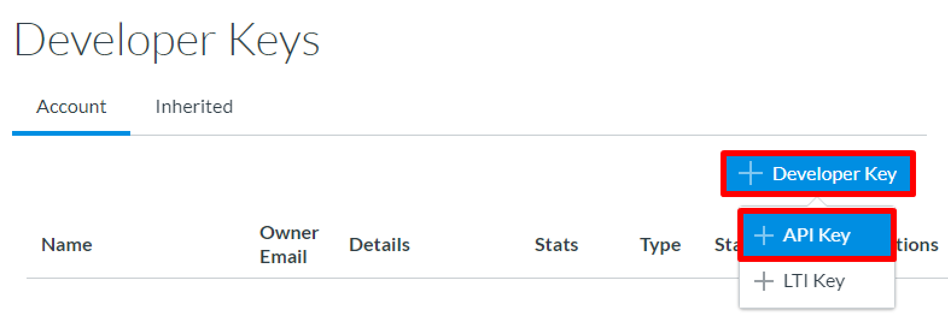
- Enter the following information on the ‘Key Settings’ screen:

- Key Name: The key name can be created according to your school’s standard naming conventions. (If you are unsure of your school’s naming conventions, consider using ‘C4ELink LTI Application.’)
- Owner Email: itteam@c4edu.com
- Redirect URI (Legacy): https://ltiapp.c4elink.org/manage_content
- The ‘Enforce Scopes’ button can remain in the ‘OFF’ position, if you wish. This setting would mean that all API scopes will be available to the C4E Application.

Key Settings (Scopes Not Enforced)
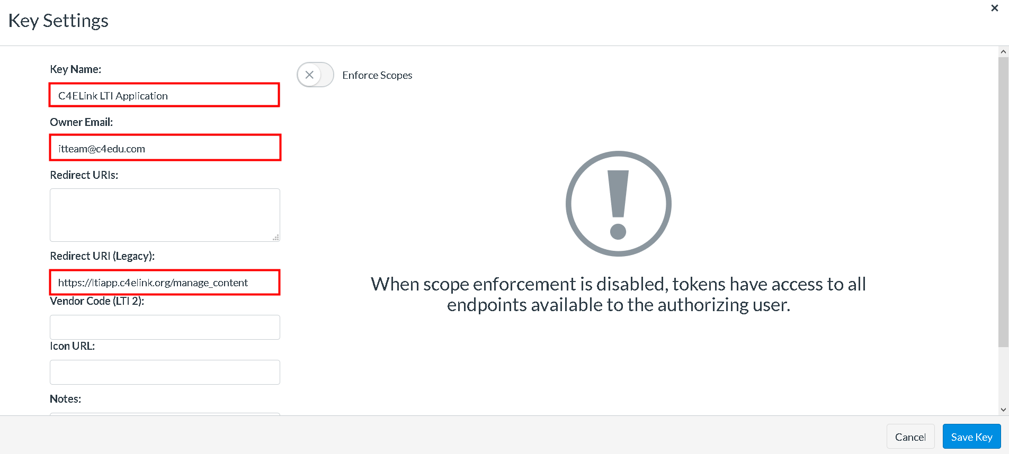

- If you would prefer to restrict the C4E Application to only the required API scopes, you can toggle the ‘Enforce Scopes’ button to the ‘ON’ position and define the following scopes for deep link integration (listed is the API along with the header under which the scope is listed):

  - url:POST|/api/v1/courses/:course_id/assignments - Assignments
  - url:GET|/api/v1/courses/:course_id/external_tools - External Tools
  - url:POST|/api/v1/courses/:course_id/external_tools - External Tools
  - url:GET|/api/v1/courses/:course_id/modules - Modules
  - url:GET|/api/v1/courses/:course_id/modules/:id - Modules
  - url:POST|/api/v1/courses/:course_id/modules - Modules
  - url:POST|/api/v1/courses/:course_id/modules/:module_id/items - Modules

Key Settings (Scopes Enforced)
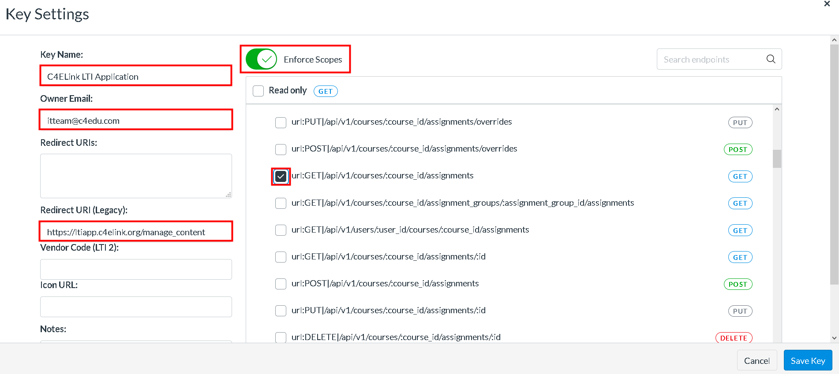

Note: If the ‘Enforce Scopes’ button is not present, you may have an older version of the Canvas LMS and the completion of this prompt is not necessary.

- Once you have completed the necessary fields, click the ‘Save Key’ button.

- On the ‘Developer Keys’ summary page, set the ‘State’ of the key to ‘ON.’
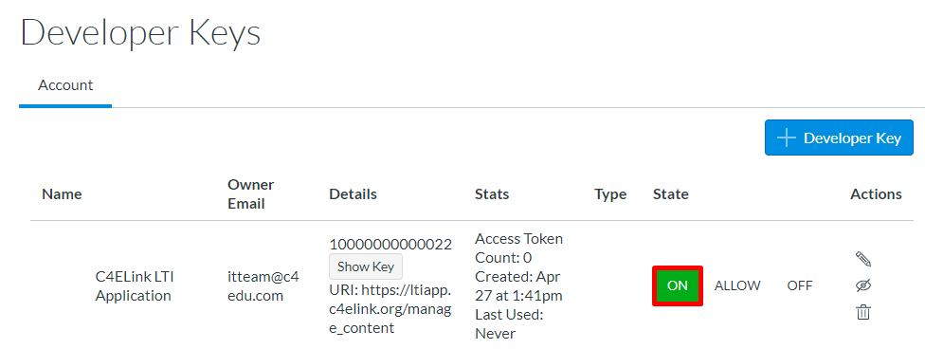

Step 2: Notify C4E

*This step will only need to be performed once. If your school has previously used deep link Integration for Connect For Education courses, this step can be skipped.
Once the Developer Key has been added to your Canvas system (Step 1), please provide our Support Team with:
- Your Canvas root URL
- Your Key ID (i.e., 1000000000022)
- Your Key (i.e., lWJ1FyY18AG8dPWjicoS8XQ9w1d3i4LBOtcgCDjKh1gPsBTnPNTPXKyoowAxmeE3)
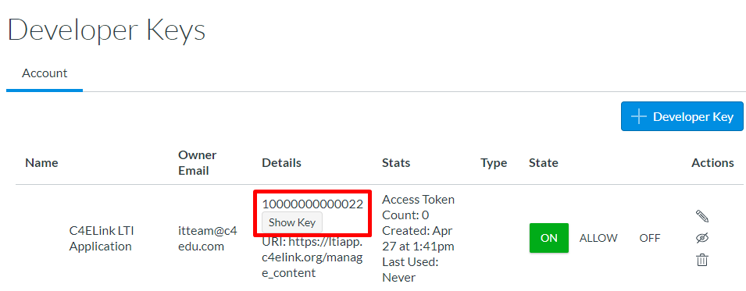

We will need this information to add your college/university as a ‘New Canvas Client’ to facilitate the remaining integration.
Once this step is complete on our end, we will work to build your new Connect For Education course and will provide you with a confirmation email containing the next steps!

Step 3: Create the Deep Linking App in Canvas
Please proceed with this step only after you have received your Course Confirmation email from the Connect For Education Technical Support Team, and after you have verified that no further changes are necessary for your course. Ideally, ALL course customizations should be addressed prior to completing the remaining steps outlined in this document.

- Log into your Canvas account and access your course shell.
** If you are teaching multiple sections, you will need to access each course
shell individually to create the LTI link. **

- From the Course Navigation panel (left-side menu), click the ‘Settings’ link.

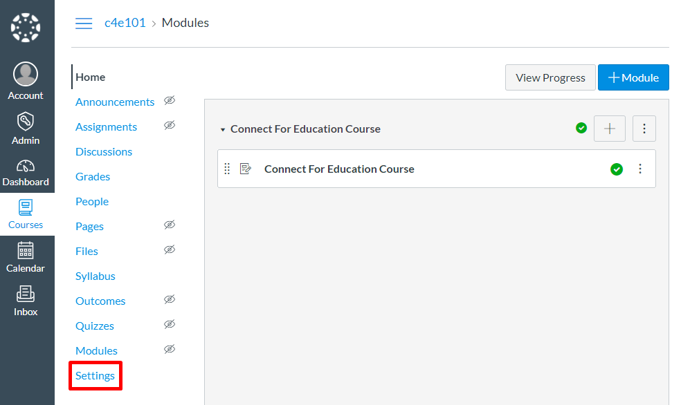

- From the ‘Settings’ page, select the ‘Apps’ tab.

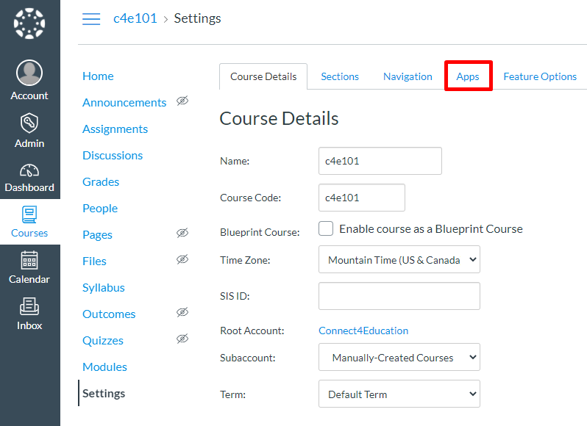

- From the ‘Apps’ page, click the ‘+ App’ button. This process will create the external link needed for the LTI integration from your school’s Canvas environment to the C4E environment.

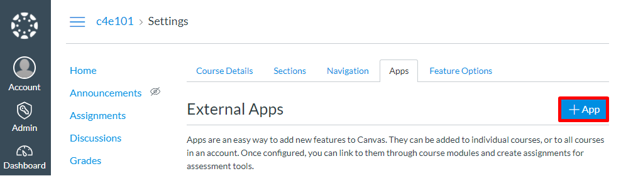

If you do not see the ‘+ App’ button initially, please click the ‘View App Configurations’ button. This should display the screen where the ‘Add App’ button is present:

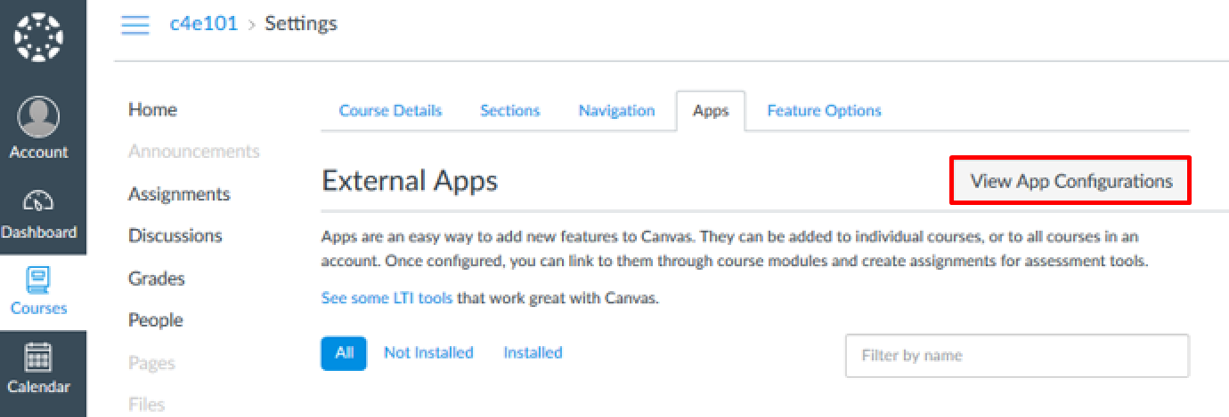
- Complete the following fields in the ‘Add App’ pop-up window:

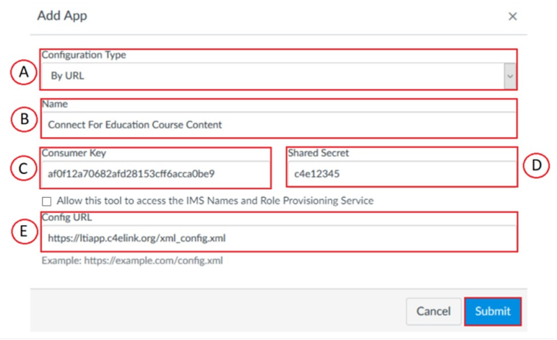

  - Configuration Type: Select ‘By URL.’
  - Name: Enter a name for the link in the Name field. Often the name of the course text is used (i.e. OnMusic Appreciation Content). For easy access, we recommend prefixing the name with a ‘0’ or ‘001’ to ensure this main LTI connection appears at the top of the list.
  - Consumer Key: Enter the ‘Consumer Key’ provided by C4E.
  - Shared Secret: Enter c4e12345
Note: The ‘Allow this tool to access the lMS Names and Role Provisioning Service’ setting should remain unchecked.
  - Configuration URL: Enter the ‘Configuration URL’ provided by C4E (https://ltiapp.c4elink.org/xml_config.xml)

- Click ‘Submit.’

Step 4: Import Your Course Content

- From the Course Navigation panel (left-side menu), click the ‘Modules’ link.
- From the ‘Modules’ page, click the ‘+ Module’ button to add a new module to the course:

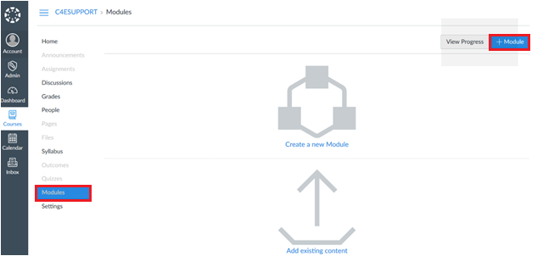

- For the Module name, enter ‘C4E App Launch’:

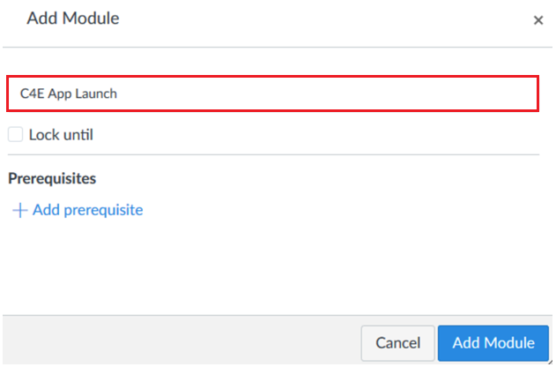

- Click ‘Add Module.’

Note: As this module will only be accessed for admin purposes, it can remain in ‘Unpublished’ status and should not be published.

- Click the ‘+’ icon (far-right) to add to the module:

- Select ‘External Tool,’ and click the blue hyperlink for the newly-created tool:
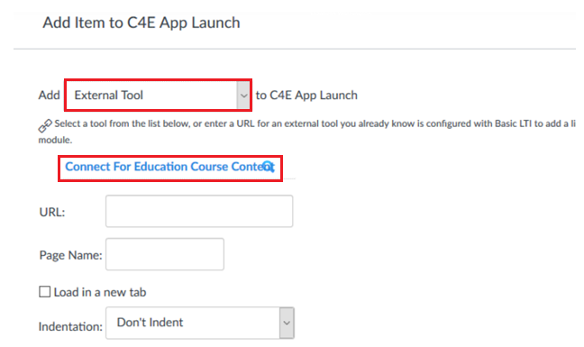

- When prompted, click ‘Authorize’ to authorize the app’s access.
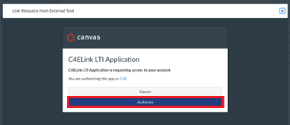
- On the content selection screen, use the ‘Select All’ option in the dropdown menu to import all course modules:

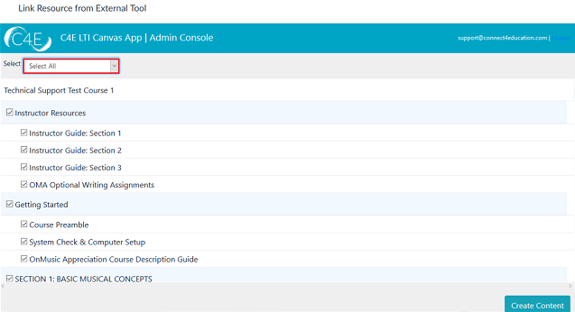

Alternately, you may select individual modules by clicking the checkboxes to the left of each desired module:
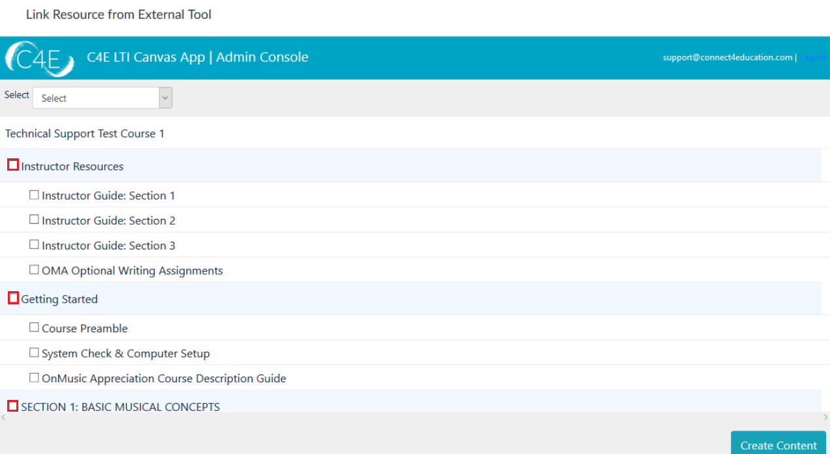

Please note, once all content has been pulled in the first time, this process should only be repeated for newly created items (i.e., new discussion forums created after the initial content pull). Pulling content that has already been imported will result in duplication.
- Once you have selected the content you wish to import, click the ‘Create Content’ button (bottom-right). This will bring you to a confirmation screen, allowing you to review the selected content:
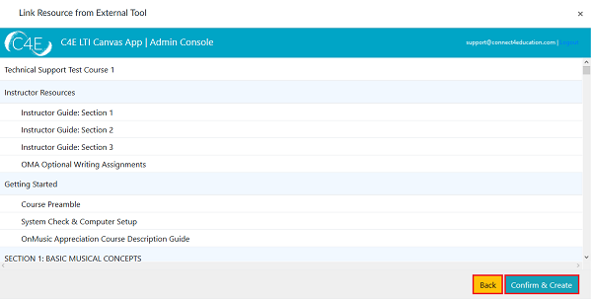
If any adjustments are necessary, simply click the ‘Back’ button to return to the content selection screen. Otherwise, click ‘Confirm & Create’ to start the content creation process. Depending on the amount of content selected, this process may take a few minutes.
- When the content creation process is complete, click ‘Leave Page’ on the confirmation screen:

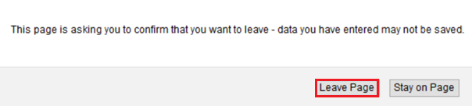

- Once the content has populated, the ‘C4E App Launch’ module will need to be removed. Click the three stacked dots to expand the Additional Options menu:
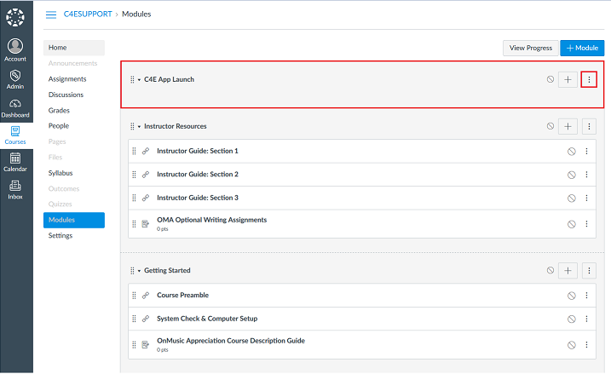

- Click ‘Delete’ to delete the module:

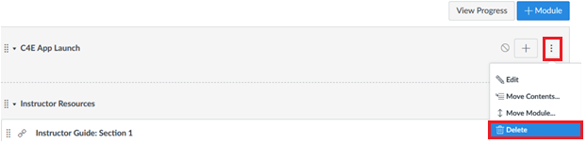

- After deleting the ‘C4E App Launch’ module, each individual module on your ‘Modules’ menu will need to be published. To publish, click the Publish icon to the right of each individual module (this will publish all items within the module):

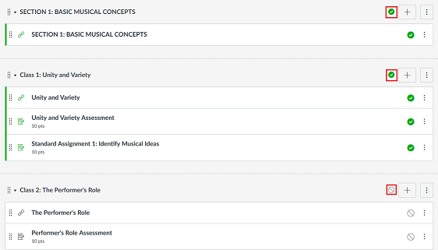

The ‘Publish’ icon may vary depending on which version of Canvas your school uses. Typically, once the module is published, the icon will go from gray to green. Please also note, to make this course available to students once it has been finalized, you will also need to publish the entire course, as discussed later in this document.

Step 5: Setting Up Your Gradebook
Once your course content has been pulled into your Canvas course shell, all coursework items will be listed under a generic ‘Assignments’ group in the gradebook. You will need to setup your Canvas gradebook to mirror the weights/values of the Connect For Education gradebook. This will ensure the accuracy of all grades being passed back. Please note that this process may vary if your Connect For Education gradebook is set to a flat gradebook, and does not feature any weighted categories.
    - From the Course Navigation panel (left-side menu), click the ‘Assignments’ link and select the ‘+ Group’ button:
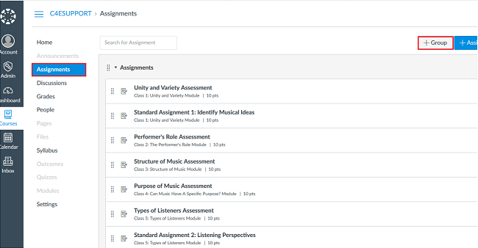
    - Enter the name of the desired group (i.e., Quizzes) and click ‘Save’:
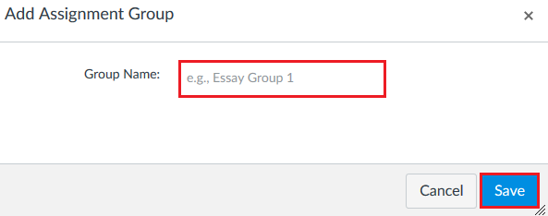
You will need to repeat this step to create all remaining gradebook groups.

Tip: if your course contains many quizzes, it might be helpful to rename the original ‘Assignments’ group to ‘Quizzes,’ therefore eliminating the need to move each and every quiz into a new group. To rename, simply click the three stacked dots to expand the Additional Options menu, and select ‘Edit.’

    - Once your groups have been created, use the Drag buttons to the left of each coursework item to drag and drop into the correct assignment groups (i.e., move the Midterm Exam into the corresponding ‘Midterm’ group):
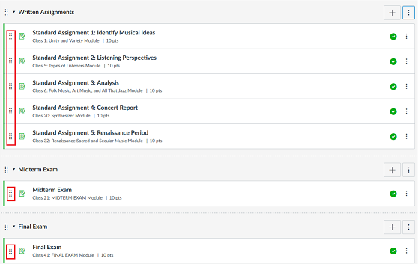

    - After the groups have been arranged, the next step will be adjusting your group weights to match the category weights of the Connect For Education gradebook. Click the three stacked dots to the right of ‘+ Assignment’ to expand the Additional Options menu:

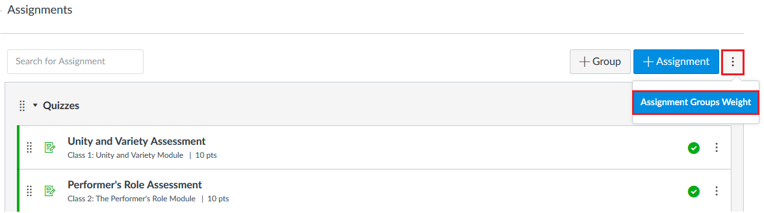

    - Check ‘Weight final grade based on assignment groups,’ adjust your weights accordingly, and save:
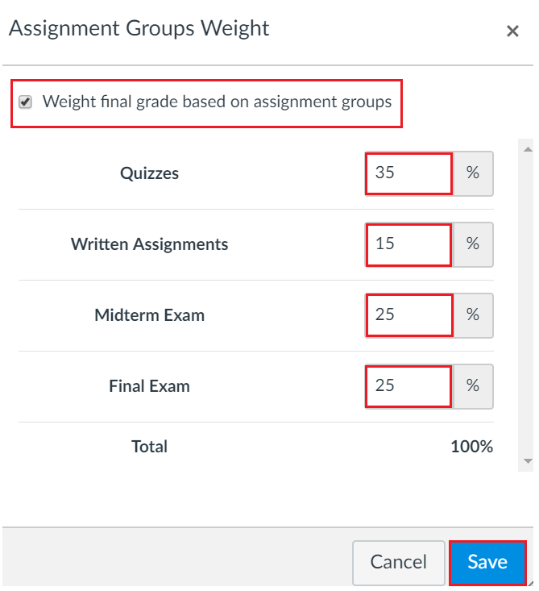
Percentages will update to the right of each group heading:
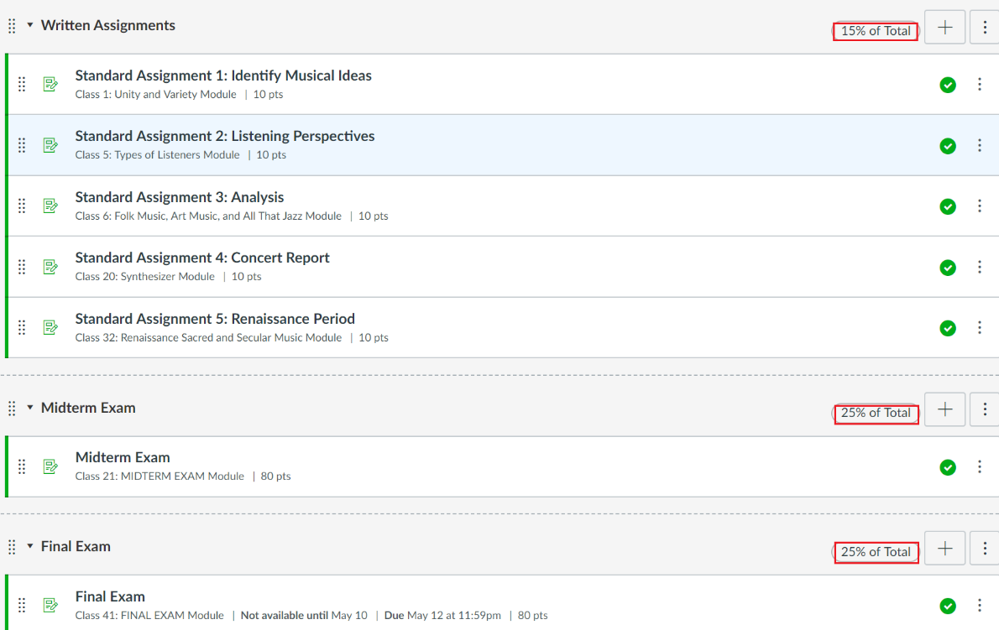
Please note, any manually-added gradebook items previously created in the Connect For Education gradebook will not carry over and will need to be recreated in your Canvas gradebook.
    - Once your gradebook has been fully setup, you may publish your course by clicking the ‘Publish’ button on the right-side of your course Home page:
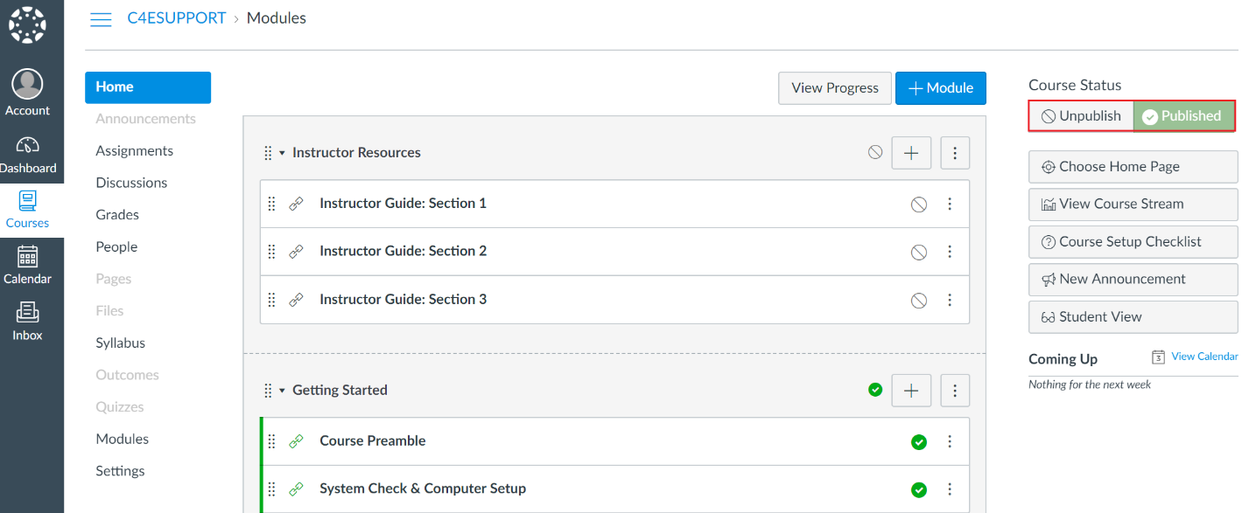

Making Changes in Your Course

- Prior to importing content into your Canvas course shell, we encourage you to complete any customizations to your Connect for Education course on the C4E LTI course site (https://lti.c4elink.org/).

- Please note, once all content has been pulled in the first time, this process should only be repeated for newly created items (i.e., new discussion forums created after the initial content pull). Pulling content that has already been imported will result in duplication.

- With LTI integration, please be aware that you essentially have two course shells (one on Canvas and one on Connect For Education’s LTI course platform). Once Connect for Education course content has been imported into your Canvas course shell, you must be cautious to maintain consistency between the course shells when making any changes. To prevent confusion, we strongly recommend mirroring your Canvas course structure with the course structure on Connect For Education’s LTI site.

- As grades are synced regularly, there may be a very short amount of time where grades will be blank.

- The table below provides guidance on some common changes. As you will see, some changes can be made exclusively on the Canvas side, while others will require you to complete the changes on BOTH platforms (Canvas and the Connect For Education LTI site).

Types of Changes | Location of Change
Grading written assignments | When grading written assignments, you may do so directly from the C4E grading tool, which can be accessed from the Canvas assignment. This will record the grade on the C4E LTI course site, which will then be passed back to the Canvas gradebook during the grade sync.
Calculating final grades/Entering zeros for unsubmitted items | To calculate final grades, zeros will need to be manually entered for all unsubmitted course work. You will need to enter zeros directly in the Canvas gradebook. This cannot be done on the C4E LTI course site. We recommend performing this step very soon after an assignment deadline has closed, and once you are certain students can no longer submit this item. If assignments remain open after zeros have been entered, students will be able to complete the assignments and the grade they receive will override the zero with an updated score.
Adjustments to student grades | We recommend making all grade changes directly at the C4ELink LTI site. Doing so will ensure that the correct grade remains in the Canvas gradebook. Please be aware that any grade changes made in Canvas may be overwritten if there is an update to the grade in C4ELink.
Setting or adjusting class deadlines | We advise that all deadlines be implemented on the Connect For Education LTI course site to prevent any unnecessary confusion.
Modifying exam times or number of attempts for specific students | This will need to be done using the ‘User overrides’ feature on the Connect For Education LTI course site.
Modifications to existing assignment or discussion forum text* | This can only be completed on the Connect For Education LTI site.  *Forums implemented directly in the Canvas LMS are an exception, and can be modified from Canvas.
Course/lesson ordering | While the course/lesson ordering can technically be different in Canvas, we suggest making changes on both platforms for the sake of consistency.
Adding announcements | As the Connect For Education course does not offer an ‘Announcements’ block, course announcements should be implemented in Canvas.
Creating new discussion forums | While new discussion forums can be created on either platform, forums created on the Connect For Education LTI site after course content has been pulled will need to be added in individually using the steps outlined earlier in this document.
Moving or deleting items | We suggest making changes on both platforms for the sake of consistency. Exercise caution when removing graded items from the course. You may need to review the impact on your course gradebook. If a quiz is being moved or removed, consider that the quiz questions may also be included on the Midterm/Final and may need to be adjusted.
Adding files/documents | While this can be done in either platform, files and documents added in Canvas may be more easily accessed by students. Files/documents added on the Connect For Education LTI site after course content has been pulled will need to be added in individually using the steps outlined earlier in this document.
Modifying point values for quizzes, assignments, and/or forums | To ensure accuracy of synced grades, this will need to be done on both platforms.
Modifying Gradebook structure/course grading scheme | As the gradebook is facilitated in Canvas, all adjustments must be maintained in Canvas. If you choose to reference the Connect For Education LTI course site for student grades, changes should be made there as well.
*If you are interested in making a modification to your course and are unsure where a change should be made, please contact Connect For Education Technical Support and we would be happy to provide guidance.

Calculating Final Grades in Canvas

As a reminder, we recommend performing this step very soon after an assignment deadline has closed, and once you are certain students can no longer submit this item. If assignments remain open after zeros have been entered, students will be able to complete the assignments and the updated scores they receive will override any entered zeros.
Please also note, the grade sync process is unable to transmit grade values that exceed 100%. As a result, any course totals that exceed 100% (as a result of extra credit) will be transmitted to your Canvas gradebook as 100%.

    - Access your gradebook.

    - Locate the assignment you wish to enter zeros for.

    - Hover over the assignment title and click the downward arrow icon.

    - Select ‘Set Default Grade’
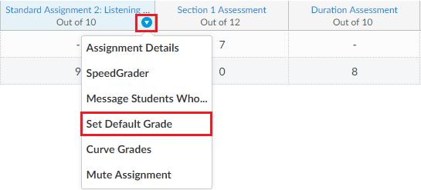

    - Enter ‘0’ in the ‘out of’ field. Do NOT check the ‘Overwrite already-entered grades’ option as this will override all existing grades and enter zeros for those who have already completed the work and received a grade.
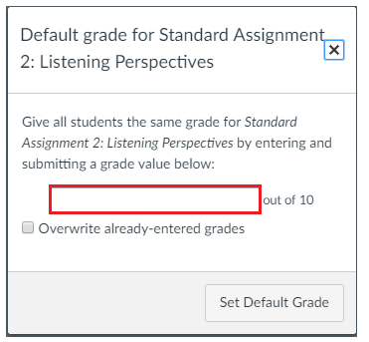
    - Click ‘Set Default Grade.’ This will populate zeros in all empty grade fields for this assignment.

    - Repeat as necessary for all remaining assignments.

